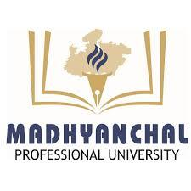

MADHYANCHAL PROFESSIONAL UNIVERSITY, BHOPAL (M.P.)

POST-EVENT REPORT OF YOUTH DAY CELEBRATION HELD ON 12-March-2026 WITH THE THEME “SDGi hackathon 2.0”

Event Overview

- Date 12 March 2026
- Venue: Computer Lab
- SPEAKER’S: -Mr Ranjan sahni
- DR. Sameena Zafar Ma’am (Deputy Deen) ,Abhilasha Garg Ma’am (DSW Incharge)
- Coordinators:
- Mr. Ranjan Sahni Assistant Professor, CS Department MPU
- Md Imran Ansari Assistant Professor, CS Department MPU
- .Ms Afreen Khan Assistant Professor, CS Department MPU

Purpose

The purpose of organizing the Club Activity on 12 March 2026 with the theme “SDGI Hackathon 2.0” was to guide students in registering for the Hackathon coding test and creating their professional profiles on LinkedIn. The activity aimed to encourage students to participate in technical competitions, improve their coding skills, and build a professional online presence. It also helped students understand the importance of networking and career opportunities in the technology field.

Measures of Success

Measure | Actual
The success of the SDGI Hackathon 2.0 activity was measured through active student participation, teamwork, creative ideas, and their ability to develop innovative solutions to given problems. | The activity was successfully conducted with enthusiastic participation from students. They actively shared ideas, worked in teams, and demonstrated creativity and problem-solving skills during the Hackathon.

Key Achievements and Recommendations

Achievements
• Achievement #1: Successfully organized the SDGI Hackathon 2.0 Club Activity and guided students for Hackathon coding test registration.
• Achievement #2: Helped students create and set up their LinkedIn professional profiles to improve their online presence and career opportunities.
• Achievement #3: Achieved active participation from students with enthusiastic involvement during the registration and profile creation process.
• Achievement #4: Encouraged students to participate in technical competitions and coding activities to enhance their technical skills.
• Achievement #5: Improved students’ awareness about professional networking, career development, and industry opportunities through LinkedIn.

Recommendations
• Recommendation #1: Organize more technical activities such as coding challenges and hackathons to improve students’ practical skills.
• Recommendation #2: Conduct sessions to guide students on creating professional profiles on platforms like LinkedIn and other career networks.
• Recommendation #3: Arrange workshops on coding, problem-solving, and technical competitions to prepare students for hackathons and industry-level challenges.
• Recommendation #4: Collect feedback from students after the activity to understand their learning experience and improve future club activities.

Budget

Budgeted Income | NIL
Budgeted Expenses | Nil
Actual Income | Nil
Actual Expenses | Nil

Attendance

Number of Participants | 23
Number of Attendees | 23

Venue:-

Computer Lab

Observations and Recommendations

• Many students initially had limited awareness about Hackathon participation and coding competitions; therefore, similar technical awareness programs should be organized regularly.

• Students showed strong interest in coding tests and technical activities; hence, more hackathons and coding practice sessions are recommended.

• High levels of participation and interaction were observed during the registration and LinkedIn profile creation process; similar career-oriented activities should be conducted in the future.

• Students understood the importance of professional networking through LinkedIn, so more sessions on career development and online professional platforms are suggested.

• Students expressed interest in learning more about coding and technical skills; therefore, organizing workshops and training sessions is recommended.

Feedback

• Participants expressed satisfaction with the organization of the SDGI Hackathon 2.0 Club Activity.

• Students found the activity helpful for registering in the coding test and understanding the Hackathon process.

• Many students appreciated the guidance provided for creating and improving their LinkedIn professional profiles.

• Students reported that the session increased their interest in coding competitions and technical activities.

• Feedback indicated that students would like more such technical workshops and hackathon-related activities in the future.

Social Media Mentions

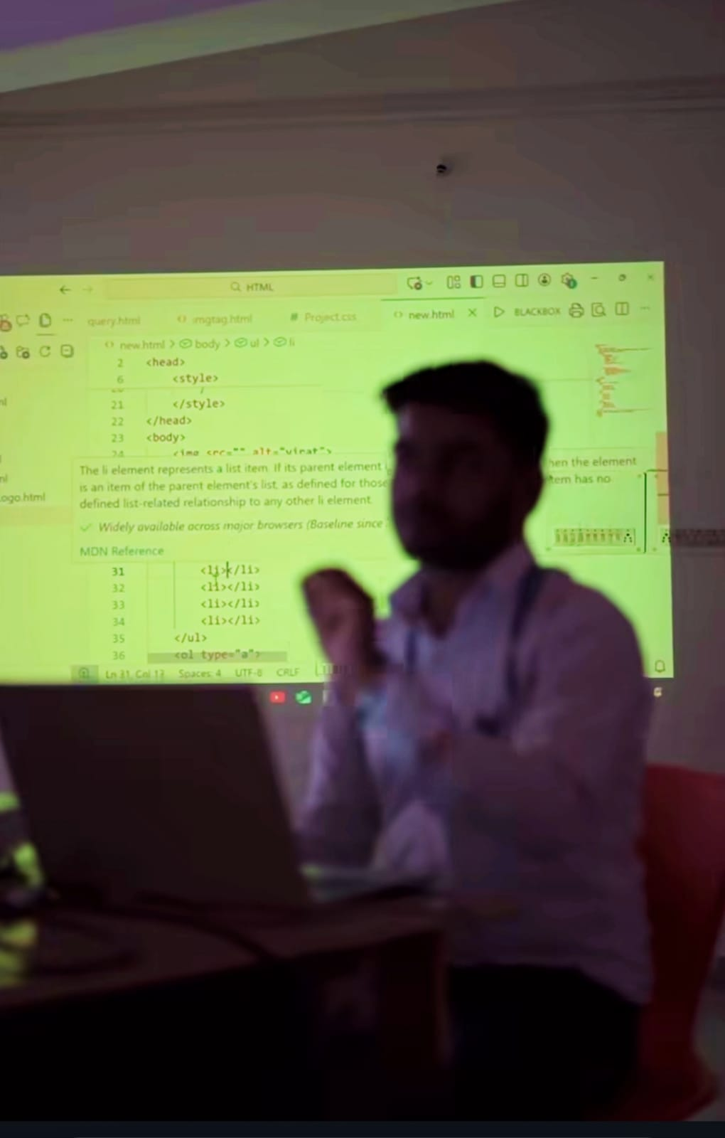

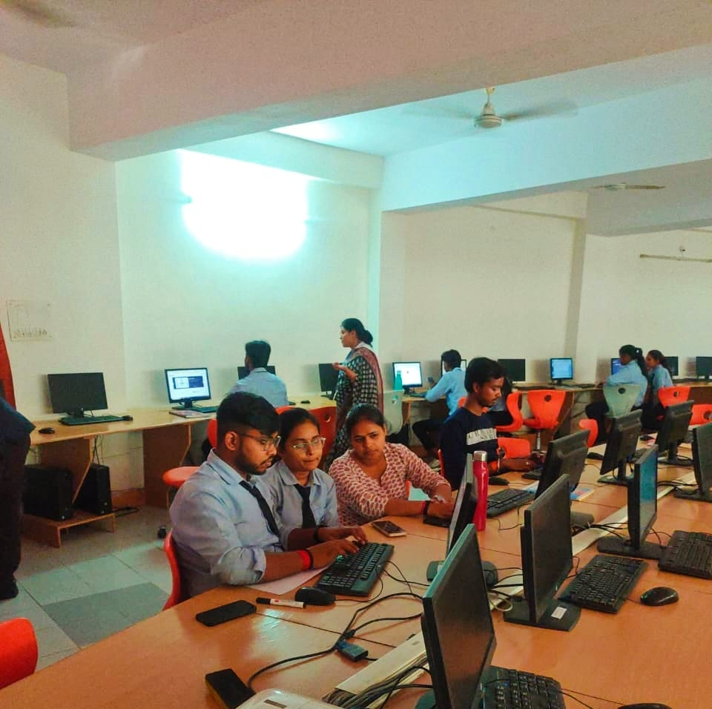

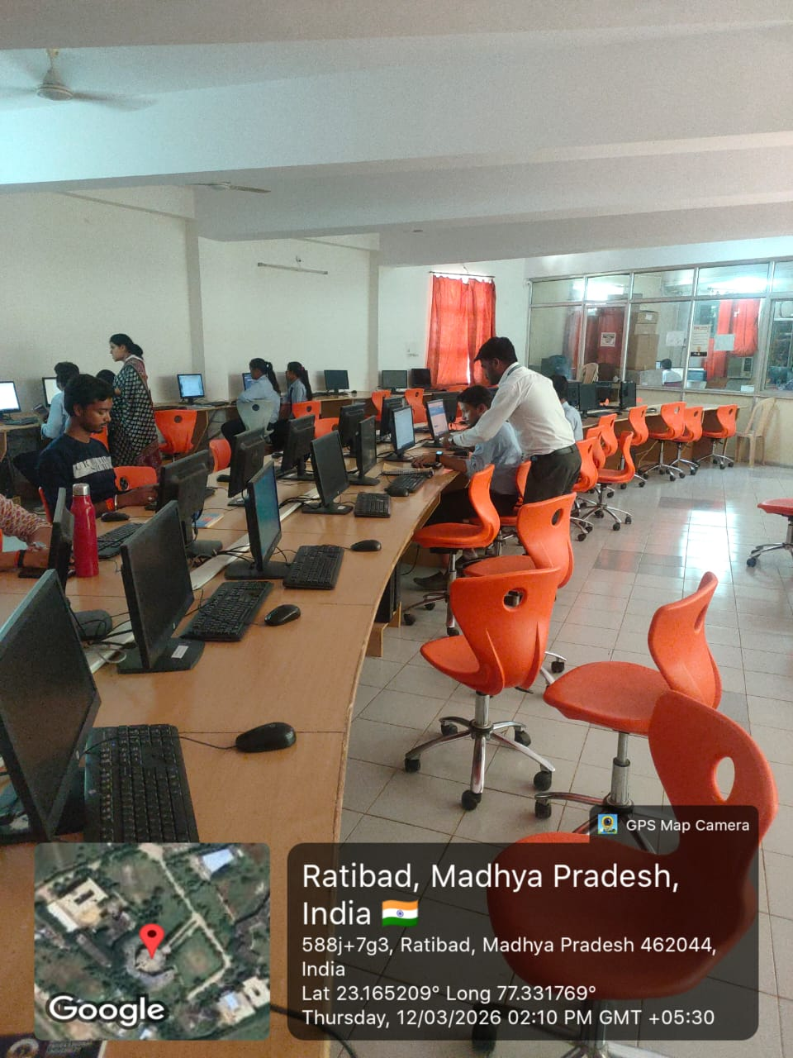

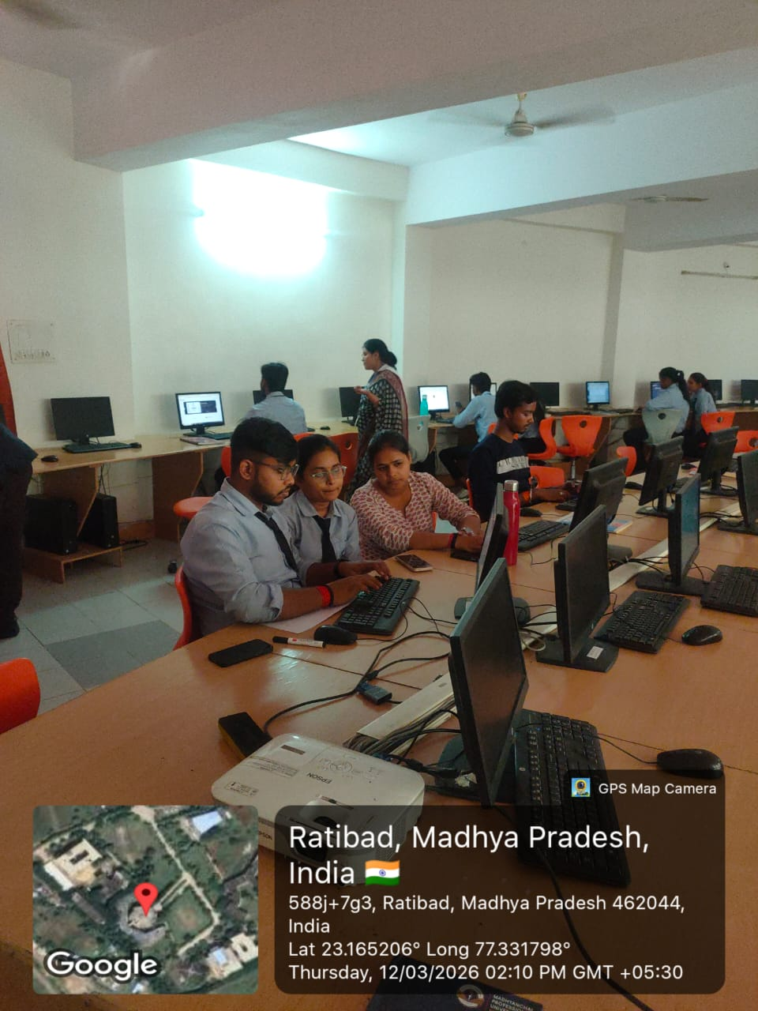

Sponsors
CS department

Event Promotion

Summary of Promotional Activities

Activity | Reach
Add detail here. | WHATSAPP GROUP
Add detail here. | FACEBOOK
Add detail here. | THROUGH MAILS

Summary of Social Media Activity

 | Before Event | After Event | % Growth
Face book Page | YES | YES | 70
Face book Event | YES | YES | 70
Instagram | YES | YES | 70
LinkedIn Shares | YES | YES | 70
Twitter Posts | - | - | -
Hash tag Mentions | - | - | -

- Pictures from social media posts

Event Gallery
